Technical Report
Date | Name | Product | Brand | Model | Test
12/02/13 | George V | Tape Machine | Otari | MX55 | Spectrum - Azimuth

These printouts are the results from a Sabrent Technologies External Converter at 48KHz conversion and 24 bit.

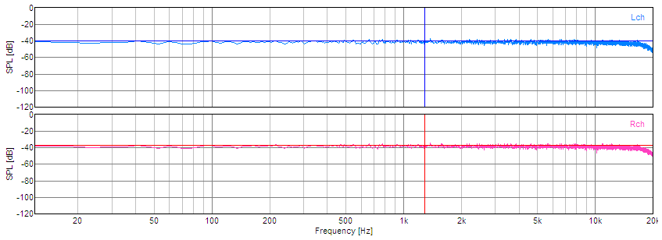
Input monitor through electronics
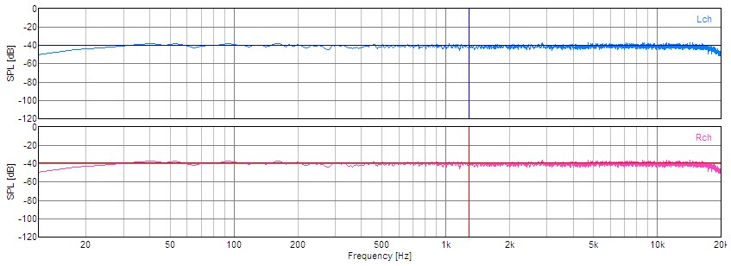
Output monitor High Speed Record Play
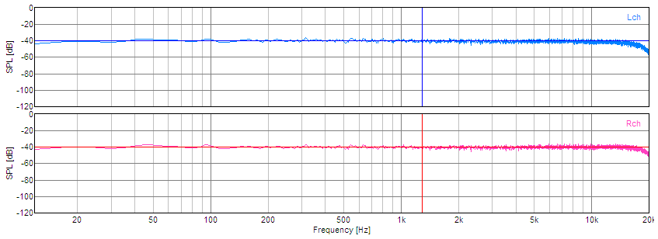
Output Monitor Low Speed Record Play
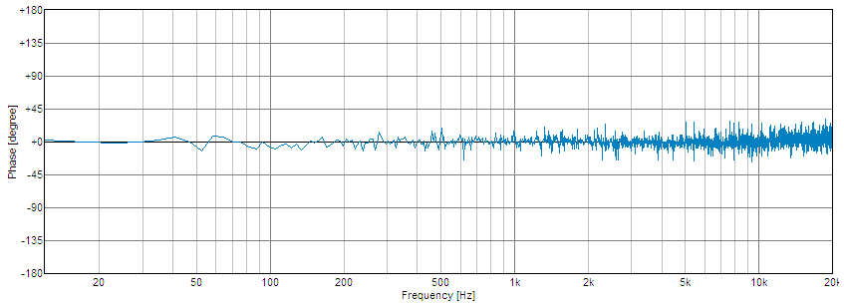
Phase Correlation – Head Phase / Azimuth over Entire Spectrum

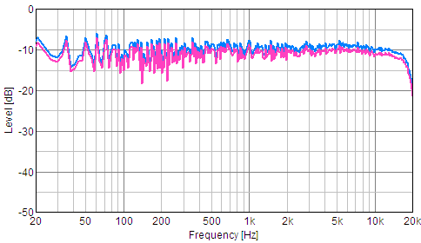
High Level Record Spectral Response

Summary: Machine in good condition. Will eventually require head re-lapping. Oxide builds up at flat spot. Slight motor bearing noise at high speed. Calibration controls well within operating centers.

